**EXHIBIT IX – APPENDIX 1**

**HSE OFFSHORE ACTIVITIES**

**FPSO PETROBRAS XX (P-XX)**

**SUMMARY**

1. **OBJECTIVE**
2. **DOCUMENTS**
   1. Reference Documents
   2. Additional Documents
3. **DEFINITIONS**
4. **KICK-OFF MEETING & BEGINNING OF WORKS**
5. **PDCA CYCLE FOR HSE MANAGEMENT SYSTEM**
   1. Plan
   2. Do
   3. Check
   4. Act
6. **HSE SPECIFIC REQUIREMENTS FOR OIL & GAS INDUSTRY**
   1. General requirements
   2. Workforce requirements
   3. Personal Protective Equipment (PPE)
   4. Machines, equipment and tools
   5. Planning
   6. Protection of the environment
   7. Emergencies in operational areas
   8. Suspensions of services due to HSE issues
   9. Audits and inspections
   10. Electrical works
   11. Radiation sources
   12. Confined spaces
   13. Cargo handling (lifting and hoisting)
   14. Hydro-blasting
   15. Hot Work and activities with potential generation of ignition sources
   16. Mechancal treatment and painting
   17. Working with dangerous products
   18. Working at height
   19. Hydrostatic and tightness test
   20. N.A.
   21. N.A.
   22. Works in areas with H2S presence
   23. N.A.
   24. N.A.
   25. Diving operations
   26. N.A.
   27. Activities over the sea

1. OBJECTIVE

The objective of this APPENDIX is to establish BUYER HSE requirements that shall be complied with by SELLER.

* 1. This document establishes SELLER's obligations and responsibilities, guidelines and procedures concerning Occupational Health, Safety Rules and Regulations, and Environmental Protection (HSE) activities that must be complied with by SELLER.
  2. This document also establishes the SELLER obligations and responsibilities, guidelines and procedures that must be complied with, as a result of the execution of the agreement, whenever performed on the BUYER UNIT on offshore phase.
  3. In case SELLER outsources its work scope, the subcontractor and / or assignee and their workers must meet all HSE requirements of this APPENDIX.

**2. DOCUMENTS**

**2.1. Reference Documents**

2.1.1. HSE Policy.

2.1.2. BUYER HSE Rules and Procedures mentioned on this APPENDIX.

2.1.3. BUYER SELLER Base Management Improvement Program – PGBF

2.1.4. HSE Golden Safety Rules (Addendum 1).

**2.2. Additional Documents**

1. BS OHSAS 18001:2007 – Occupational Health and Safety Management System
2. ABNT NBR ISO 14001:2004 – Environment Management Systems
3. NRs - Regulatory Standards issued by Brazilian Ministry of Labor and Social Security.
4. HSE requirements contained in the Federal Constitution, Laws, Decrees, Ordinances, Normative Instructions and Resolutions, at the federal, state and municipal levels, and rules of ABNT NBR, regulatory agencies, supervisory agencies and classification societies, when associated with the current legislation.
5. Law 8.213, dated july 24, 1991 – Provides for Social Security Benefit Plans and other measures.
6. ABNT NBR-14280 – Occupational Accident Record (CAT) – Procedure and Classification.
7. Reports templates – FIA, RMA e REM (Addendum 2).
8. Resolution ANP nº 43/2007 - Establishes the operational safety system for oil and natural gas drilling and production facilities and approves the SGSO technical regulation for oil and natural gas drilling and production facilities.
9. Resolution ANP nº 44 of dec 22,2009 – Establishes the procedure for reporting incidents, to be adopted by companies authorized by the ANP to carry out the activities of the oil, natural gas and biofuels industry, as well as distribution and sale.
10. Resolution ANP nº 37/2015 - Regulates the cases in which SSM Inspection Agents may grant time for the companies to adjust their conduct to the provisions of applicable legislation and E&P contracts for oil and natural gas, without the immediate application of the penalties provided by Law No. 9.847, of Oct 26, 1999.
11. Resolution ANP nº 41/2015 - Approves the SGSS technical requirements.
12. Resolution ANP nº 46/2016 - Establishes the requirements and guidelines for the implementation and operation of a SGIP, in order to protect human life and the environment, the integrity of the assets of the Union, third parties and the contract operator. The SGIP must be applied throughout the life time of wells for E&P activities regulated by ANP.
13. NORMAM 24/DPC - Institutions accreditation to provide Complementary Courses and Training.
14. DNSST Normative Instruction nº 01, of April 11, 1994.
15. CNEN - NN 3.01 - Basic Guidelines for Radiological Protection.
16. CNEN - NE 5.01 - Transport of Radioactive Materials (Resolution CNEN 013/88).
17. NFPA 2112 - Standard on flame-resistant garments for protection of industrial personnel against flash fire.
18. ASTM D 6413 - Standard test method for flame resistance of textiles.
19. ASTM F1930 - Standard test method for evaluation of flame-resistant clothing for protection against fire simulations using an instrumented manikin.
20. Federal Test Method Standard 191A, 1534.
21. ABNT NBR 5410 - Low voltage electrical installations.
22. ABNT NBR 6494 - Safety in scaffolding.
23. ABNT NBR 12176 - Cylinders for gases - Identification of the content.
24. ABNT NBR 14725 - Chemicals - Information on safety, health and the environment - Part 4: Chemicals Safety Data Sheet (MSDS).
25. ABNT NBR 15292 - High visibility safety clothing.
26. ABNT NBR 15475 - Rope access - Qualification and certification of professional.
27. ABNT NBR 15595 - Rope access - Procedure for applying the method.
28. ABNT NBR 16577 - Confined space - Accident prevention, procedures and protective measures.
29. ABNT NBR IEC 60079 - Explosive atmospheres.
30. ABNT NBR 61892 - Fixed and mobile marine units - Electrical installations – Part 1: General requirements and conditions.
31. N-2163 - Welding and tapping in equipment, pipelines and ducts when in operation.
32. Petrobras N-2344 - Safety in industrial radiography works.
33. Petrobras N-2869 - Safety in cargo handling.
34. Petrobras N-2918 - Explosive atmospheres - Classification of areas.
35. PE-1PBR-00208 - Safety Manual (MS).
36. PE-1PBR-00210 - MS – Permit to work.
37. PE-1PBR-00211 - MS - Simultaneous work and operations.
38. PE-1PBR-00212 - MS - Preparation and release of equipment for intervention.
39. PE-1PBR-00213 - MS - Electrical work.
40. PE-1PBR-00214 - MS - Confined space work.
41. PE-1PBR-00215 - MS - Working in cargo, ballast and slop tanks of FPSO, FSO and FPU.
42. PE-1PBR-00216 - MS - Access, working and emergency assistance in FPSO, FSO and FPU pump room.
43. PE-1PBR-00217 - MS - Working in areas with H2S presence.
44. PE-1PBR-00218 - MS - Working at height.
45. PE-1PBR-00219 - MS - Working at height - Rope access.
46. PE-1PBR-00220 - MS - Working at height - Scaffolding.
47. PE-1PBR-00221 - MS - Diving operations.
48. PE-1PBR-00222 - MS - Working over the sea.
49. PE-1PBR-00223 - MS - Cargo handling.
50. PE-1PBR-00224 - MS - Cargo handling - Cranes.
51. PE-1PBR-00225 - MS - Cargo handling – Chain Blocks, trolley hoists, overhead cranes and derricks.
52. PE-1PBR-00227 - MS - Working with dangerous products.
53. PE-1PBR-00228 - MS - Working with dangerous products - Laboratories.
54. PE-1PBR-00229 - MS - Working with hazardous products – Cylinders containing compressed gases.
55. PE-1PBR-00230 - MS - Working with dangerous products - Explosives.
56. PE-1PBR-00231 - MS - Working with hazardous products - Use of sources of radiation.
57. PE-1PBR-00232 - MS - Hot Work and activities with potential generation of ignition sources.
58. PE-1PBR-00233 - MS - Abrasive blasting works.
59. PE-1PBR-00234 - MS - Mechanical treatment and painting works.
60. PE-1PBR-00235 - MS - Hydro blasting.
61. PE-1PBR-00236 - MS - Pneumatic tests and hydrostatic tests.
62. PE-1PBR-00240 - MS - Air transport of people.
63. PE-1PBR-00241 - MS - Maritime transport of people.
64. PE-1PBR-00242 - MS - Land transportation of people.
65. PE-1PBR-00243 - MS - Transfer of people by personnel transfer basket.
66. PE-1PBR-00494 - Selection, procurement and use of professional uniforms and PPE.
67. PP-1PBR-00150 - Analysis and Treatment of HSE Non-conformities

# Note 1: The rules and standards (laws, decrees, resolutions, normative instructions, guidelines, procedures and technical rules) mentioned in this APPENDIX have the function of providing a reference for the conduct of activities. It is SELLER obligation to verify the rule / standard to be applied in each specific activity to be performed, checking for any updates or modifications and their applicability.

# Note 2: The applicable BUYER internal standards, guidelines and procedures, under the guidance of the BUYER HSE, are made available by the BUYER contract management to the SELLER representatives.

**Note 3:** The SELLER must present the certificates and documents that prove the training of its employees and subcontractors in the regulatory standards considering the applicability and work activity.

**3. DEFINITIONS**

Definitions are those adopted by ABNT, ISO and OHSAS Standards, complemented by:

**ABNT:** Brazilian Association of Technical Standards.

**ANP:** Brazilian National Agency for Petroleum, Natural Gas and Biofuels.

**APR:** Preliminary Risk Analysis **(PRA)**.

**ART:** Technical Responsibility Notation **(TRN)**.

**ASO:** Occupational Health Certificate **(OHC)**.

**CAT:** Occupational Accident Record **(OAR)**.

**CBSP**: Basic Platform Safety Course.

**CCF:** Final Completion Certificate **(FCC)**

**CIPA**: Internal Commission for Accident Prevention.

**CLT:** Brazilian Consolidation of Labor Laws Decree.

**CNEN**: National Nuclear Energy Commission.

**Conform:** It is a checklist (LV) requirement that is being complied regarding legal and BUYER’s subscribed requirements.

**Critical Element**: equipment, system or critical procedure for operational safety. Critical equipment is any equipment or structural element of the installation that could, in the event of failure, cause or contribute significantly to a near miss or an operational accident. Critical system is any engineering control system that has been designed to keep the installation within safe operational limits, to stop all or part of the installation or a process in the event of a failure in operational safety or to reduce human exposure to the consequences of any failures. Critical procedure is a procedure or criteria used to control operational risks.

**Critical deviation:** Deviation with the possibility to cause a high potential incident or class 4 or 5 HSE non-conformity.

**Critical non-conformity (CR):** Non-conformity that may cause serious and imminent risk to people, the environment, the installation or operations. Corrective action must be immediate.

**Deviation:** Any action or conditions with potential for causing direct or indirect injuries to persons, asset damages (own or of third parties) or environmental impact, that is not in conformity with work standards, procedures, legal or standard requirements, management system requirements or good practices.

**DNSST**: National Department of Occupational Health and Safety.

**DR**: Diferencial Residual (Residual Differential).

**DSMS:** HSE Daily Dialogue (Daily Toolbox Meeting) **(HSEDD)**.

**EBT**: Extra Low Voltage **(ELV)**.

**EPI:** Personal Protective Equipment **(PPE)**.

**EPR**: Breathing Apparatus.

**FIA:** Accident Information Form

**First Aid case**: as defined by BUYER’s document PP-1PBR-00150, in order to monitor HSE performance indicators.

**FISPQ**: Material Safety Data Sheets **(MSDS)**.

**FPSO**: Floating Production Storage and Offloading

**FPU**: Floating Production Unit

**FSO**: Floating Storage and Offloading

**HHER:** Quantity of man-hours exposed to risk in a given period.

**HUET**: Helicopter Underwater Escape Training.

**High potential incident:** Incident that could have caused death, permanent disability, material damage classified as major or impact on the environment classified as major.

**IMC**: Body Mass Index **(BMI)**.

**Incident:** Unpredicted and undesirable event that could have resulted in injuries to a person, asset damages (own or of third parties) or environmental impact.

**INMETRO**: National Institute of Metrology, Standardization and Industrial Quality.

**Integration:** Process of training / briefing the new employee about the BUYER’s premises, facilitating his adaptation in the new work scenario in which he starts his professional activities.

**IPS:** Safe Practices Index.

**Leadership:** It is all BUYER’s management professionals, including President, Director, Executive Manager, General Manager, Manager, Sector Manager, Contract Manager, Contract Inspector, Coordinators, and Supervisors or equivalent.

Leadership is also the entire SELLER’s management team, as Directors, Managers, Coordinators, Supervisors and Persons in Charge.

**LIE**: Lower explosive limit **(LEL)**.

**LII**: Lower flammable limit **(LFL)**.

**LV:** Checklist **(CL)**.

**Mild non-conformity (LE):** Deviation or isolated failure in meeting a HSE requirement, as long as it does not qualify as Critical, Serious or Moderate. Corrective action must be carried out up to 180 days, which may be reduced depending on the specific nature of the service.

**Moderate non-conformity (MO):** Partial or insufficient compliance with an Operational Safety Management System requirement, or HSE requirement. Corrective action must be carried out up to 90 days, which may be reduced depending on the specific nature of the service.

**Non-conformity:** It is a failure to meet one or more of legal and BUYER HSE requirements.

**Not inspected:** It is a requirement that appears in the checklist (LV) and is part of the CONTRACT's scope, but cannot be inspected due to a relevant fact, for example, physical progress at the time, not allowing a satisfactory analysis of the operation risk.

**NR:** Regulatory Standards issued by Brazilian Ministry of Labor and Social Security

**Operational Safety Management System (SGSO)**: Regulatory structure that aims the operational safety of offshore drilling and oil and natural gas production facilities, established by ANP Resolution 43/2007.

**OPITO**: Offshore Petroleum Industry Training Organisation.

**PAD:** Deviation Management Program.

**PCMSO:** Occupational Health Control Program **(OHCP)**.

**PPR**: Respiratory Protection Program **(RPP)**.

**PPRA:** Environmental Risk Prevention Program.

**PRE:** Emergency Response Plan.

**Pressurized Compartment:** Closed compartment with positive pressure to perform hot work in a classified area or areas with the possibility of the presence of flammable gases or vapors, this equipment must be mobilized by the SELLER.

**PT:** Permit to Work **(PTW)**.

**Qualification:** process of making people and teams able to perform certain activities, applying knowledge and skills to carry out their functions and / or assignments.

**RCD:** Residual-Current Device.

**Recom:** Communication Net.

**REM:** HSE Monthly Report.

**RF**: Fire Resistant **(FR)**.

**RMA:** Monthly Summary of Accidents Report.

**Serious non-conformity (GR):** Lack of an Operational Safety Management System requirement. Relevant failure to meet an Operational Safety Management System requirement, or HSE requirement. Corrective action must be carried out up to 30 days, which may be reduced depending on the specific nature of the service.

**SESMT**: Specialized Service in Safety Engineering and Occupational Medicine.

**SISPAT**: SELLERs’ Provider Data Management (BUYER’s System).

**Systemic Deviation:** Set of deviations or similar deviations that occur repetitively.

**Systemic Incident:** Set of incidents or similar incidents that occur repetitively.

**T-HUET**: Tropical Helicopter Underwater Escape Training.

**VCP:** Verification of Procedures Conformity **(VPC)**.

**4. PLANNING MEETING FOR THE START OF OFFSHORE WORKS**

Compliance with HSE requirements will be discussed and planned at a specific meeting, with attendance of BUYER’s inspection team and HSE representative, SELLER's Project Manager, HSE Manager and working coordinating team.

This meeting must take place at least 90 (ninety) days before the start of offshore activities.

At this meeting, BUYER will present the following information and documents:

* Information on physical, chemical and biological risks, in order to support the preparation of the Environmental Risk Prevention Program (PPRA), Occupational Health Control Program (OHCP) and associated programs.
* Procedures and standards for the execution of services, such as Permit to Work (PTW), Emergency Response Plan (PRE) and Risk Management.
* Mandatory training for offshore phase, with the exception of those required by law, will have a minimum training hour stipulated for each worker function. BUYER is responsible for preparing the material.
* Ensure that in case of outsourcing its work scope or contracting a third party SELLER, the subcontractor / third party SELLER will meet the HSE requirements.
* Take actions in case of stopping or suspending services due to HSE issues.
* Monitor HSE performance indicators and establish their calculation method.
* Define and comply with timing of HSE meetings.
* Issue HSE reports.
* For works carried out in brazilian sites, present proof of enrollment in the Working / HSE competent agencies, including obtaining the ART, in addition to: CREA registration (Regional Council of Engineering and Agronomy) or another class body, registration of SESMT as per NR-4, prior communication of the beginning of services to the local SRTE (Regional Labor and Employment Superintendence) and others.
* Present the Responsibility Assignment Matrix, including subcontractors.
* Conduct HSE checks, inspections and audits.
* Present a system that ensures the implementation of SELLER's HSE Working Discipline, as well as a HSE Compliance Treatment System, both considering BUYER's HSE Golden Rules.
* Present all mandatory licenses and / or protocols required by competent agencies.
* Present the documents PCMSO, PPRA, PRE and others.
* For works carried out in brazilian sites, present a report on dangerous activities and operations performed by SELLER's workers, in accordance with brazilian law (CLT, art. 193).
* Present SELLER training and awareness program (training matrix covering legal and contractual training, workers certification control, etc.)
* Critical elements list.
* Issue of operational procedures and procedure for analysis and treatment of non-conformities.
* If applicable, comply with any action plan created to mitigate non-compliance items found during HSE inspections / audits.

The issuing of identification badges for SELLER's employees access to the UNIT (offshore phase) are subject to delivery of all documents / evidences and their updates, mentioned in this requirement, and to the attendance of BUYER’s HSE training (integration and specific for the activity). SELLER's HSE programs and plans may require updates after information and documents delivered by the BUYER.

SELLER shall present the documents / evidences above, 60 (sixty) days before sailaway to final location, and shall keep them updated.

**5. PDCA CYCLE FOR HSE MANAGEMENT SYSTEM**

The specific conditions of HSE management, to be complied by SELLER, described below, are based on and structured in the PDCA management cycle (plan, do, check and act, as details below) and complement the item 2.2. (Additional documents).

* Plan: to establish processes and objectives necessary to obtain the results in accordance with the HSE policy.
* Do: to implement the processes.
* Check: to monitor and measure the processes in relation to HSE policy, HSE objectives, the appropriate use of resources (human, equipment, tools, etc.), legal and other requirements, and report the results.
* Act: to take actions to continually improve HSE performance.

The HSE management system must be based on the requirements of the Management Standards, in order to provide a view of HSE to the BUYER, and must be validated by the BUYER.

SELLER shall submit to BUYER the HSE management system, not later than 60 (sixty) days before start the offshore phase, containing the requirements of this APPENDIX and following items:

**5.1. Plan**

**5.1.1. HSE Managemnent Policy**

The SELLER must implement an HSE Management Policy, based on ISO 14001, BS OHSAS 18001 and the PBA (Basic Environmental Plan as required by IBAMA), and disseminate it to all levels of workers. Policy must contain at least the following items:

**5.1.2. HSE risk identification, assessment and control**

SELLER shall:

a) know and identify aspects and hazards in any activity to be carried out, in order to assess the risks and impacts;

b) implement actions to prevent and control the assessed impacts and risks, through a system that shall be accepted by BUYER.

**5.1.3. Change Management**

SELLER shall:

a) know and identify, in a systematic way, the changes in installation, technology and people that may occur, when performing any work. SELLER shall not carry out any changing in BUYER’s facilities without BUYER previous authorization.

b) know and identify the variables affected by the change and the new associated risks.

c) establish the necessary actions to mitigate the new risks.

d) present a system for controlling the changes.

**5.1.4. Legal requirements and others**

SELLER shall:

a) comply with the HSE legal requirements, rules and procedures for operational control that are applicable to its activity.

b) present an identification and control system, capable of checking any changes in legislation (federal, state or municipal), conventions, collective labor agreements and applicable rules in addition to this APPENDIX.

**5.2. Do**

**5.2.1. Resources and responsibilities**

SELLER shall:

a) detail the HSE organizational structure and keep it updated. Stucture shall be composed of: Responsibility Assignment Matrix and list of all qualified professionals with their respective certificates.

b) keep updated the HSE documents for subcontractors and third party SELLER employees available for BUYER check and auditing.

c) Comply with NR-4 and NR-37 requirements for staff qualification of the SESMT. For the dimensioning, the contractor must consider the sum of employees and subcontractors, keeping at least 1 (one) offshore HSE professional regardless of the number of employees and subcontractors and 1 (one) onshore coordinator.

d) N.A.

e) Ensure that overtime and / or night services (weekdays, Saturdays, Sundays and holidays) are attended by HSE staff.

f) N.A.

**5.2.2. Competency and qualification training**

SELLER shall:

a) attend all trainings required by local authorities and also required by BUYER (integration and specific by activity), and shall present a training control system.

b) attend specific training for requesting Permit to Work (PTW).

c) N.A.

d) N.A.

e) N.A.

f) N.A.

g) N.A.

**5.2.3. Communication**

SELLER shall:

a) establish a HSE communication program, including its monitoring system.

b) Inform to all workforce the HSE agreement requirements, alerting about the relevant aspects and risks, as well as the possible injuries and damages.

c) establish HSE Daily Toolbox Meeting (DSMS), according to the activities to be carried out, containing the dissemination of good practices, lessons learned, HSE alerts, points of attention and guidance contents received from BUYER and subcontractors through the Communication Net (Recom).

d) inform the corrective and preventive actions resulting from accidents, incidents and deviations to all its employees, including the actions taken by BUYER.

e) at least every year, in one of the construction sites, the SELLER's leadership must attend a HSE inspection and a formal HSE meeting.

When requested, SELLER's workforce must attend HSE events and meetings sponsored by BUYER.

**5.2.4. Operational Control**

5.2.4.1. Operational discipline

SELLER shall:

a) ensure its workforce is aware and comply with the applicable HSE local legislation and BUYER’s HSE rules and procedures.

b) establish a systematic HSE compliance assessment that shall include ways to take appropriate measures in case of non-compliances. In addition, perform a critical analysis of the compliance treatment system, verifying the result of the HSE performance indicators.

c) comply wth the specific requirements of BUYER as per item 6 of this APPENDIX

5.2.4.2. Waste management and disposal

SELLER shall:

a) participate in BUYER's environmental programs and implement its own program considering its activities.

b) establish a systematic monitoring of the waste management and disposal program.

5.2.4.3. Energy isolation/lock-out/tag-out

The SELLER must follow BUYER energy sources isolation control system for equipment and systems, in which the energization, start-up, product leakage and the stored residual energy dissipation or release may occur unexpectedly, which can cause injuries and other damages.

**5.2.5. Emergency response**

SELLER shall:

a) follow the guidelines established in BUYER integration training.

b) have an emergency response plan for first aids that shall be available to the workforce.

c) implement a procedure contemplating emergency response to all risk scenarios that may occur due to their activities, through a system accepted by the BUYER.

d) N.A.

**5.2.6. Procedures/Standards**

SELLER must implement HSE procedures/standards in accordance to this APPENDIX, with emphasis on critical operational activities.

**5.2.7. Documentation**

SELLER must keep updated and archived all HSE documents related to the agreement during the legal time required by the law. For those documents without time definition by law, SELLER shall keep for a period of 5 (five) years from the signature of the CCF.

**5.3. Check**

**5.3.1. Performance monitoring**

SELLER shall:

a) comply with HSE performance indicators presented at the kick-off meeting, implement an action plan for achieving the established goals, and a system to control the results.

b) monitor following indicators:

* Fatal accidents or serious environmental damage.
* Lost Time Injury Frequency – LTIF (Taxa de frequência de acidentados com afastamento – **TFCA**)

TFCA = (NCAX106)/HHER, where:

NCA: number of lost time injury cases (sum of fatalities and lost work day cases)

HHER: total number of man-hours exposure to risk in the given period

* Total Injury Rate (Taxa de ocorrências registráveis – **TOR**)

TFSAs1 = (NARX106)/HHER, where:

NAR: Total quantity of typical cases, with lost-time or not, including first aids.

HHER: total number of man-hours exposure to risk in the given period

* Total Recordable Injury Rate (Taxa de acidentados registráveis – **TAR**)

TAR= (NARs1 X 106)/ HHER, where:

NARs1: Total quantity of typical cases, with lost-time or not, excluding first aids.

HHER: total number of man-hours exposure to risk in the given period

* Severity Rate (Taxa de gravidade – **TG**)

TG = (TCA X 106)/HHER, where:

TCA: injury lost-time shall be calculated according to the requirements of ABNT NBR 14280.

HHER: total number of man-hours exposure to risk in the given period

* number of non-conformities notifications from HSE local agencies inspections
* lost-time due to illness or accident, occupational or not
* percentage of leave by ICD 10.

Nota: At BUYER’s discretion, other performance indicators in compliance with specific conditions can be defined.

**5.3.2. Accident management, investigation, reporting and learning process**

SELLER shall:

a) in the event of an accident, attend the injured person, communicate INSS (National Institute of Social Security) by means of a report (CAT) and deliver copy of the report to BUYER.

b) implement an accident investigation and communication procedure, and a program to record and monitor the application of HSE recommendations from the accident investigation and deliver the REM.

c) report immediately to BUYER the occurrence of any accident or incident, involving its employees or subcontractors.

d) deliver the FIA, together with the CAT, indicating the measures to be taken. In the event of accidents causing lost time of workers from SELLER or its subcontractors, SELLER will be called to attend a meeting at BUYER's facilities to provide necessary clarifications regarding the accident and the corrective and preventive measures he is adopting.

e) deliver the REM until the 5th (five) day of the following month (even if no accident occurred in the period), including copy of the CAT and the accident investigation (if applicable).

f) deliver the RMA until the 5th (five) day of the following month, whenever there is an accident with lost time and until employee returns to work, together with the calculation memory of the HHER. The data necessary for completing this table is available at ABNT NBR-14280.

Note: The provisions of this APPENDIX do not exempt the SELLER from:

* Issue the CAT, as required by Law 8,213, of July 24, 1991.
* Comply with any other requirement of current legislation.

**5.3.3. Assessments and diagnostics**

SELLER shall:

a) provide necessary information to BUYER during HSE inspections, audits, checks and safety walk-throughs. Also implement an inspection and audit program to check the HSE management system, to identify and correct situations that present HSE risks.

b) implement an inspection program, to identify and correct situations that present HSE risks.

c) elaborate a treatment plan for identified non-conformities, considering their respective corrective and preventive actions. The actions shall be informed to all those working, according to severity classification and within the deadlines set out below:

* Critical Non-Conformity (CR) – immediately.
* Serious Non-Conformity (GR) - up to 30 (thirty) days, which may be reduced depending on the specific nature of service.
* Moderate Non-Conformity (MO) - up to 90 (ninety) days, which may be reduced depending on the specific nature of service.
* Mild Non-Conformity (LE) - up to 180 (one hundred and eighty) days, which may be reduced depending on the specific nature of service.

d) include in the non-conformity treatment plan accidents, high potential incidents, critical and systemic deviations.

**5.3.4. Records control**

SELLER shall:

a) implement a system that guarantees the record, update, filing and recovery of HSE information, in order to demonstrate the conformity of the HSE management system and its effective operation.

b) keep updated and archived all HSE documents related to the CONTRACT during the legal time required by the law. For those documents without time definition by law, SELLER shall keep for a period of 5 (five) years from the signature of the CCF.

c) record and pass on to the BUYER, the good practices that bring gains in HSE when identified.

**5.4. Act**

**5.4.1. HSE critical analysis**

SELLER shall:

a)  Present a critical analysis of its performance in HSE. The presentation shall be done by its leadership on a monthly basis.

b)  Present an action plan resulting from the SELLER's critical analysis; and evidence that such plan is being followed.

**5.4.2. Final HSE review**

The SELLER must submit a final HSE performance assessment report, according to the requirements of Addendum 3 - Post-Closing Assessment.

1. **SPECIFIC HSE CONDITIONS FOR OFFSHORE PHASE** 
   1. **General requirements**
      1. Lack of knowledge by SELLER or its subcontractors of the rules and regulations of Industrial HSE are not accepted, even though they are not attached to this document, as such information is easily available by legal agencies and by the BUYER for consultation.
      2. SELLER shall request from BUYER information on potential risks, in order to assist on the elaboration of specific programs on HSE and the issuance of technical reports for special workers retirement purposes as per brazilian working legislation.
      3. SELLER is responsible, when applicable, for issuing hazardous / unhealthy reports for dangerous / unhealthy activities and operations, in accordance with current legislation. These reports must be submitted for analysis by BUYER before being submitted to the official inspection agencies.
      4. SELLER must keep the PPP (“Perfil Profissiográfico Previdenciário”) of its employees available, as well as provide a copy of it when requested by BUYER or in case of discharge of its employee.
      5. N.A.
      6. SELLER, according to NR-5, must present a document proving the installation of the CIPA. When required by BUYER, SELLER shall nominate one employee, from its workforce, to attend the BUYER’s CIPA meetings.
      7. During offshore phase, SELLER shall also comply with requirements of NR-30 e NR-37.
      8. SELLER must implement HSE Training and Reviewing Program for its workers, compatible with the risk assessment and HSE regulations. SELLER shall also establish a system to check the Program performance.
         1. Trainings shall include, in addition to those already mentioned in this annex, the legal and specific for each nature of activity.
         2. SELLER must present evidences of HSE training.
      9. N.A.

* + 1. SELLER shall provide following training and certification:

1. for all its personnel that will embark on the UNIT for more than 03 (three) consecutive days, the CBSP (Basic Platform Safety Course) in accordance with NORMAM 24.
2. N.A.
3. for all its personnel subject to embark by helicopters transport, the T-HUET (Tropical Helicopter Underwater Escape Training) or HUET (Helicopter Underwater Escape Training), held by a Training Center certified by OPITO (Offshore Petroleum Industry Training Organization).
4. Personnel who will work in instrumentation and electrical activities, the training of Electrical Installations in Explosive Atmospheres (Classified Areas).
   * 1. To allow embarking, SELLER must provide the list of its employees who will provide service on board the UNIT (filling out the SELLER's Employee Identification form), so that BUYER can include them in the Service Provider Data Management System (SISPAT).
     2. Only workers who are properly trained and included in SISPAT System are allowed to carry out services on board. They shall comply with following requirements:
5. Submit the certificates of CBSP, NR-20 and T-HUET (or HUET) courses, according to item 6.1.10.
6. Worker SISPAT registration is subject to the validity of the ASO and respective certificates of HSE mandatory courses.
7. Presentation of the Occupational Health Certificate (ASO) that shall be in accordance to the work carried out by the employee and in accordance with the PCMSO.
8. For offshore phase, employee cannot have a Body Mass Index (BMI) equal to or greater than 40. An employee with a BMI greater than or equal to 35 must be included in a specific monitoring program and accompanied by SELLER's health service. SELLER shall inform BUYER its contingent in such condition.
9. Employee may lose his qualification once a non-compliance is verified, through audits or checks, performed by the BUYER or by another agency.
10. In cases where the SELLER’s employee, or any of its subcontractors, embarks with any kind of pathology and there is a need to disembark, this must occur through administrative procedure and not by a medical one, and the SELLER must bear all the costs.
11. SELLER must arrange, without cost to BUYER, the immediate replacement of its employee, whose health condition does not meet the health conditions required for the work.
    * 1. SELLER must implement a cleaning and house-keeping program related to the scope of this Agreement.
      2. SELLER must keep the jobsite clean, organized and signaled.
         1. N.A.
      3. DSMS must be held before starting operational activities, in order to discuss the tasks that will be carried out, the work process, risks and preventive actions.
         1. In shift changes and workers teams changes, DSMS must also include discussions on changes in the process and interventions in equipment and systems that may have an impact on operational safety, and this information must be recorded and entries traceable.
      4. N.A.
      5. SELLER must keep updated and archived all HSE documents related to the CONTRACT during the legal time required by the law. For those documents without time definition by law, SELLER shall keep for a period of 5 (five) years from the signature of the CCF.
      6. During the term of the AGREEMENT and during the term of custody of the documentation, SELLER must grant BUYER access to all HSE documentation whenever requested.
      7. SELLER must present an HSE management plan, with measurable goals and objectives and based on the requirements of the Management Standards, in order to provide an HSE vision and disseminate best practices for the development of a safety culture, with active participation of the leadership.
      8. SELLER must present a system to implement and monitor programs and tools that work in continuous improvement and in the development of safety culture and reduction on work accident such as: verification of compliance with procedures, safety campaigns, good practice programs and operational discipline.
    1. **Workforce Requeriments**
       1. It is responsibility of the SELLER's onboard representative to direct SUPPLER’s workers as to the risks involved and the precautions to be taken in carrying out their activities.
       2. The workforce shall:
12. follow the safety standards, rules and regulations;
13. be aware and follow the safety signs;
14. attend all DDSMS, safety training and emergency drills;
15. know the site emergency plan;
16. stop the work and ask onboard leadership for advise in case of doubt or identification of a risk situation;
17. keep the work uniform clean;
18. not wear uniforms contaminated with chemicals that may pose health risks, cause skin irritation or cause ignition when in contact with fire;
19. not wear any metallic adornment or accessory and loose hair in the worksite;
20. not clean the uniform or skin with solvents, flammable products or compressed air;
21. inform onboard leadership whenever feel sick or have any health discomfort;
22. smoke only in the designated and signaled areas;
23. walk on their right side and use the handrail, when going through walkways and stairs;
24. avoid stand in places near activities in which they are not working;
25. use PPE correctly;
26. keep the worksite clean;
27. only perform jobs or tasks that they are fully aware;
28. perform their activities in areas, equipment or machines for which they are authorized and qualified;
29. immediately report any accident and / or incident; and
30. comply with HSE Golden Rules.
    1. **Personal Protective Equipment (PPE)** 
       1. SUPPLER and its subcontractors shall provide, free of charge, for all employees, PPE in perfect conditions, according to the risk identified and with NR-6. The quantity of PPE shall be enough to avoid use of PPEs without good conditions.
       2. N.A.
          1. N.A.
       3. SELLER must present to BUYER, whenever requested, the control of PPE distribution, PPE expire dates and its regular inspections.
       4. Respiratory protection equipment must comply with the control and replacement program, in accordance with Normative Instruction No. 01, 11.04.94, from DNSST.
       5. According to the activity to be performed by the worker, gloves must be used against mechanical risk of impact and crushing:
31. Guidelines for proper selection of gloves against mechanical risk of impact and crushing are described in PE-1PBR-00494.
32. Technical Specifications for gloves selection are located on Petrobras' external website in the SELLER Channel area: <https://canalfornecedor.petrobras.com.br/pt/regras-de-contratacao/catalogo-de-padronizacao/#especificacoes-tecnicas>.
    * 1. SELLER and subcontractors shall provide, free of charge, for all employees, uniforms (work clothes) with characteristics and quantities compatible with the service to be performed. The quantity of uniforms shall be at least 03 (three) complete kits.
         1. Uniforms must have RF fabric, and certified copies of test certificates must be provided by a recognized laboratory (third party), with the following test standards:
33. certificate according to NFPA 2112 for the fabric, including all tests mentioned in the certification;
34. test according to ASTM D 6413 with 0 (zero), 50 (fifty) and 100 (one hundred) washes in fabrics and trims (retroreflective or any other item that may be part of the piece externally), according to NFPA 2112 item 7.1.2;
35. test according to ASTM F 1930 item 8 with 0 (zero), 50 (fifty) and 100 (one hundred) washes;
36. Federal Test Method Standard 191A, 1534 for sewing lines;
37. all retroreflective tests according to ABNT NBR 15292.
38. N.A.
    * + 1. N.A.
        2. Uniform must contain the name or logo of the SELLER, as well as the employee's name.
        3. The uniform must be orange color.
    1. **Machines, equipment and tools**
       1. SELLER must implement a program of maintenance, inspection, calibration and tests of machines and equipment according to manufacturer instructions, in accordance with NR-12 and other applicable regulations, maintaining a systematic control to ensure the safety conditions.
       2. SELLER must implement an inspection program for hand tools and accessories, in order to ensure that they are in perfect conditions of use.
       3. Before carrying out any work, the equipment, tools and accessories must be inspected to ensure that they are in perfect condition. If any unsafe condition is noted, the SELLER must perform the immediate replacement.
       4. It is not allowed to use metal ladders for electricity services.
       5. For work on electrical equipment, hand tools must have insulation compatible with the voltage and operating conditions.
       6. Manual power tools must have double or reinforced insulation, power cable with no cuts or splices, and plugs with specific coloring and arrangement of pins, avoiding their connection to a voltage source different from that specified.
       7. Portable electrical equipment used in classified areas, such as lamps, lanterns, ventilation systems and gas monitors, must have Equipment Protection Level (EPL) compatible with the EPL of the classified area where they will be used. They must be certified according to the National Institute of Metrology, Standardization and Industrial Quality (INMETRO certificate).
          1. Portable industrial electrical equipment that produces sparks or high temperatures, such as drills, grinders and welding machines, can be used in classified areas as long as it is ensured, by monitoring, that there is no explosive atmosphere.
       8. Power cables for power tools and portable distribution panels must have insulation compatible with the working voltage, comply with NBR 5410 or NBR 61892, and must be inspected by the person performing the work to ensure that they are in perfect working condition and dry.
       9. Power tools and portable electrical machines must be powered by a circuit with protection by a residual-current device (RCD) of 30 mA.
       10. Portable luminaires must be powered by outlets with 30 mA RCD, isolating transformer or extra low voltage (EBT).
       11. Portable devices must be powered by cables with double insulation.
       12. Portable devices that do not have double insulation must be powered by cables that have a grounding conductor.
       13. For tasks that require impacts or torques, the use of hydraulic, pneumatic tools, mechanical torque or similar should be prioritized, avoiding the use of hand tools.
       14. Hoses and power connections for pneumatic or hydraulic tools must be dimensioned to withstand at least 1.5 times the operating pressures, be firmly coupled to the system and away from passage ways or protected when they need to pass through the passage way.
       15. Whip check safety cables must be used between the hose connections to prevent accident in case of unexpected disconnection.
       16. Sanders, grinders and miter saws must have a protective cover for the disc, disc compatible with machine rotation and blade suitable for application to the material to be cut.
       17. The use of mallets (sledgehammer) must be restricted to the impossibility of carrying out work with hydraulic, pneumatic tools, mechanical torque or similar, and must meet the following requirements:
39. The mallet must be specific to the type and location of the work to be performed, with no welding of any kind on the body of the mallet.
40. The impact surface of the mallet must be free of defects.
41. For areas classified as zones 0 and 1, when the use of a mallet is strictly indispensable, it must be made of nylon, rubber or non-sparking metal.
    * 1. N.A
         1. N.A.
         2. N.A.
    1. **Planning**
       1. SELLER must submit an execution procedure for its contractual activities, based on risk analysis. Recommendations must be aligned with the Safety Manual, risk management and legal requirements in force.
       2. The performance of any service must be planned in advance, with the pertinent HSE hazards analyses, defining the working routines and taking the necessary measures in order to guarantee its safe execution.
       3. N.A.
       4. SELLER employees must receive information about the risks of the tasks to be carried out and must meet the requirements of the standards of the BUYER Safety Procedure (PE-1PBR-00208 and complementary documents), applicable to the activity to be performed..
       5. The execution of works is conditioned to the Permit to Work system, according to the requirements of PE-1PBR-00210.
    2. **Protection of the environment**
       1. SELLER’s solid waste management must meet the requirements established by BUYER.
       2. N.A.
       3. N.A.
       4. SELLER must reimburse the costs and services that BUYER is obliged to assume for the assessment, recovery and monitoring of the environment, resulting from impacts caused by the SELLER or its subcontractors, during the execution of the AGREEMENT.
       5. N.A.
       6. SELLER must know and participate in BUYER's environmental programs.
    3. **Emergencies in operational areas**
       1. SELLER must prepare an Emergency Response Plan (ERP) for those emergency operations under its exclusive handling and total control (ex.: emergency land transportation to hospital). It shall be in line with the ERP of the UNIT.
       2. In the event of an emergency on the UNIT (offshore phase), SELLER must follow BUYER’s guidelines.
       3. N.A.
       4. N.A.
       5. SELLER’s employee must be released to attend emergency response training and exercises provided by the BUYER.
    4. **Suspension of services due to HSE issues**
       1. BUYER can stop any worker, work front, machine, equipment, installation, operation, activity or service, which shows a risk to the safety, health of people, the environment, property or the image of BUYER.
       2. The suspension of services due to unsafe conditions or the non-observance of HSE rules, instructions and regulations, do not exempt the SELLER from the obligations and penalties of the AGREEMENT clauses, regarding delivery time and penalties.
       3. SELLER is the sole responsible for the costs of the downtime or impact on project schedule caused by its failure to meet safety requirements.
    5. **Audits and inspections** 
       1. Petrobras shall perform, under its criteria, inspections and/or audits at work Sites for verifying HSE standards and other requirements conformity in Contractor HSE Management. Timing and scope of the inspections and/or audits shall be previously informed to the Contractor at HSE kickoff meeting.
       2. SELLER must prepare and submit to BUYER the action plan to meet the non-conformities identified in the audits and inspections. Non-conformities treatment must be carried out according to the established deadline.
       3. SELLER must implement systematic internal audits and inspections to ensure compliance with the HSE requirements as per this APPENDIX, in addition to the applicable legal requirements.
    6. **Electrical works**
       1. SELLER employees, working with electricity, must use the PPE and specific tools, receive information about the risks of the tasks and meet the requirements of PE-1PBR-00213.
       2. SELLER must present to BUYER the list of authorized and qualified personnel to work on electrical installations.
       3. Before carrying out any electrical work, the tools and measuring instruments must be inspected by the person performing the work to ensure that they are in working condition and dry.
       4. SELLER must comply with NR-10 and keep a record and traceability of all inspections and tests.
       5. Lower voltage hand tools must be of the 1 kV isolated type, and must be regularly inspected (visually) before use.
       6. Instruments probes must be compatible with the category of the respective instruments.
          1. Multimeters must be at least category III type, and must have the category marked on their body.
          2. For works on panels connected directly to electric networks and power generation systems, it must be used a multimeter of category IV type.
       7. For teams that operate and perform works on electrical systems and equipment, it must be provided a temporary grounding set, insulating blanket, body rescue stick and voltage detector, appropriate to the existing voltage levels.
       8. In operations and services performed on electrical equipment, distribution panels or electrical motor control centers, worker must have communication equipment to contact other team members or the control room.
       9. For the absence of voltage test in the de-energization process, voltage detectors must be used by approach or contact, coupled to the insulating hot rod.
       10. The use of any personal adornment for work on electricity, including metallic, coated or non-conductive materials, is not permitted.
    7. **Radiation sources**
       1. SELLER’s employees, working with radioactive sources, must use the PPE and specific tools, receive information about the risks of the tasks and meet the requirements of PE-1PBR-00231.
       2. The execution of services involving the emission of ionizing radiation is subject to compliance with the CNEN Standards, SELLER and BUYER radiological protection plans.
       3. N.A.
       4. N.A.
       5. N.A.
       6. N.A.
       7. N.A.
       8. N.A.
       9. N.A.
       10. It shall be followed the N-2344 for services that include industrial radiographs.
    8. **Confined space** 
       1. SELLER’s employees, working in confined space work, must be trained according to NR-33, use PPE and specific tools, receive information on the risks of the tasks and meet the requirements of PE-1PBR-00214.
       2. Breathing apparatus must be used, according to the UNIT's PPR. EPRs must comply with the control and replacement program, in accordance with Normative Instruction No. 01, dated April 11, 1994, of the DNSST.
       3. For authorized workers and members of the rescue team, a full body safety harness belt must be provided, with a device that allows the rescue of the worker in an appropriate and safe position.
       4. Electrically powered machines and hand tools can be used, as long as they have an overload and short circuit protection device, double isolation and RCD or isolating safety transformer.
       5. When it is impossible to reach 0 (zero)% of the LIE or LII, the electrical equipment must be certified to work in areas classified as zone 0 or zone 1, complying with ABNT NBR IEC 60079 and N-2918.
       6. In painting services performed inside a confined space, it shall be used only electrical power in EBT, according to NR-34.
       7. The use of pneumatic tools as an alternative to the use of electrically powered tools shall be prioritized.
       8. Gas detectors with sensors for O2, LIE / LII, CO and H2S must comply with ABNT NBR 16577, be direct reading, intrinsically safe, provided with alarms (visual, audible and vibration), protected against electromagnetic emissions or radio frequency interference. They must be calibrated and tested before use, and in sufficient quantity to maintain continuous monitoring of all work fronts inside confined spaces.
       9. It must be provided a test kit (calibration / function test kit) with standard gas.
       10. Rescue equipment must be in working conditions, in an easy access location and ready to use in the confined space with work in progress.
       11. For services within cargo, ballast and slop tanks, PE-1PBR-00215 must be followed.
    9. **Cargo handling (lifting & hoisting)** 
       1. SELLER’s employees working with cargo handling must use specific PPE and tools, receive information about the risks of the tasks and meet the requirements of the standards PE-1PBR-00223, PE-1PBR-00224, PE-1PBR-00225 and PE-1PBR-00226.
       2. The minimum training for operators of cranes, forklifts, hoists, cherry pickers, platforms and other machines and equipment must be in accordance to requirements of NR-11, NR-12, NR-18, NR-20, NR-26, NR-30, NR -34 and NR-35, where applicable, as well as operational training based on the equipment and accessories manufacturer's manual.
       3. Cargo handling accessories must be included in the maintenance and inspection plan, with a SWL certificate issued by the manufacturer or a recognized company. Accessories must be destroyed when they fail.
       4. SELLER must implement and monitor a traceability, conservation, maintenance, inspection and disposal program for all its cargo handling and lifting accessories.
       5. Cargo handling accessories should be inspected:
42. on receipt - to check the conformity of the material in relation to the purchase or rental order, and to check the manufacturer's quality certificate;
43. routine visual inspection - before starting cargo handling, accessories must be visually inspected;
44. complete inspection - the accessories must be inspected according to the conditions of use, with a periodicity equal to or less than 1 year.
    * 1. For steel slings, the following requirements must be met:
45. sling must not be dragged on the floor or be stuck under load;
46. sling in use must be correctly positioned on the hook saddle, with the hook safety latch closed, preventing the sling from loosening;
47. sling must be handled with care in order to avoid any damage. As soon as the damage begins, the sling must be discarded;
48. when not in use, the sling must be kept in a clean, dry and well-ventilated place, at room temperature, stored in a specific support;
49. sling must be lubricated to protect against corrosion and to reduce friction wear;
50. in addition to the information printed on the loop clip (crimp) by the manufacturer, the slings must be identified with a metal plate containing the workload capacity, the sling code and the date of its last inspection.
    * 1. For synthetic fiber lifting straps, the following requirements must be met:
51. straps must be stored in dry places and protected from sunlight and mechanical damage;
52. straps must not dry out exposed to fire or other sources of heat;
53. it is not allowed to tie knots in lifting straps;
54. straps must not be dragged over sharp edges or rough surfaces;
55. it is not allowed to lift loads with twisted straps;
56. straps that show signs of damages must be discarded;
57. straps must be identified with labels containing the manufacturer's information and load capacity.
    * 1. For extension cables, the following requirements must be met:
58. extension cable must have SWL compatible with the load to be moved;
59. extension cable hooks must not be painted and must have safety latches that do not allow accidental hooking on other loads or obstacles.
    * 1. Shackles must have four parts (body, pin, nut and counter pin).
      2. For cargo handling, the N-2869 must be complied with.
      3. The operating signaler and the operator of the hoisting equipment must have portable radios to allow proper communication once there is difficult to visualize the load.
      4. The operating signaler must have easy-to-see uniform, on day or night (for example reflective strips), that also sets him apart from other workers in the operation area.
    1. **Hydro blasting** 
       1. SELLER employees, working with hydro blasting, must use the PPE and specific tools, receive information about the risks of the tasks and meet the requirements of PE-1PBR-00235.
       2. SELLER employees must use double hearing protection (shell protector and ear plug), facial protector, PVC clothing, waterproof safety glove and long PVC boots and, when necessary, EPR.
       3. The hydro blasting pump must be equipped with a pressure limiting device compatible with the working pressure.
       4. The hydro blasting system must have its own file record, where the certificates of equipment, hoses and pressure gauges must be attached, as well as its maintenance plan.
       5. The end of the hose connected to the gun must be equipped with a protective jacket of a minimum length of 3 (three) m, made of material compatible with the working pressure.
       6. Whenever possible, rigid tubes should be used to assemble the pressurized water supply line between the pump and the power box (junction box), and this line must be anchored at a fixed point.
       7. The hose installed between the power box (junction box) and the gun must meet the maximum length defined by the manufacturer (indicated on the power box)..
       8. It is not allowed to use hoses with damages (bubbles, cracks, cuts, apparent steel mesh, etc.) or with expired date.
       9. It is not allowed to make any kind of adaptation in the hose connections.
       10. A device for retaining sparks must be provided, installed in the discharge of the pump motor, when necessary.
       11. Adequate foot protection must be provided, made of a material compatible with the working pressure, such as leather gaiters, aluminum gaiters, etc.
       12. The working site must be isolated, and warning signs appropriate to the type and pressure of the work must be installed.
       13. It is not allowed to twist or exceed the maximum radius of curvature of the hose.
       14. N.A.
       15. In case of poor visual contact between the hydro blaster and the pump operator, a means of communication or the presence of an observer must be provided.
       16. Watertight lighting powered by extra low voltage must be provided.
    2. **Hot work and activities with potential generation of ignition sources**
       1. SELLER employees, working with hot work and activities with potential generation of ignition sources, must use PPE and specific tools, receive information about the risks of the tasks and meet the requirements of PE-1PBR-00232.
       2. SELLER employees must use:
60. grinding work – hearing protection, face protection, gloves and clothing appropriate and specified for the activity.
61. cutting, gouging and welding work – leather clothing (apron, shoulder pads, sleeves, long-sleeved gloves, leggings, gaiters and hood), respiratory protection against fumes, welder mask with protection filters (lenses), safety glasses with protective filters (lenses), hearing protection according to the noise of the activity.
    * + 1. If the assistant has to approach the welder, he must use appropriate PPE.
      1. Hoses and cables must be free of defects (knots, deformation, cuts, etc.), and protected against impacts, sparks, flame heat and damage caused by friction and abrasion. The hoses must be suitable for the gases used.
      2. Hot work must only be carried out by qualified or trained workers, according to the requirements of NR-18 and NR-34.
      3. N.A.
      4. The use of flameproof canvas or blankets, and pressurized compartments, to contain sparks from welding, cutting, gouging and grinding work must meet the manufacturer's guidelines and the requirements of PE-1PBR-00232.
      5. To perform hot work (flame cut, gouging and welding) in a Zone 1 classified area or other locations with possible presence of flammable gases and vapors identified in the work risk analysis, SELLER must meet the requirements of PE-1PBR- 00232 regarding the use of a pressurized compartment.
    1. **Mechanical treatment and painting** 
       1. SELLER employees, working with mechanical treatment and painting works, must use the PPE and specific tools, receive information about the risks of the tasks and meet the requirements of PE-1PBR-00234.
       2. For mechanical treatment work, SELLER employees must wear hearing protection, safety goggles, anti-vibration gloves (when indicated) and respiratory protection to retain solid particles. SELLER safety officer, through risk analysis, must define the use of facial protector.
       3. For painting work, SELLER employees must wear safety goggles, gloves for chemicals and respiratory protection against gases and vapors.
       4. The tool power cables must have identification plates next to the plug and its handle, for correct identification when plugged to the electric power distribution board.
       5. In classified areas, the use of beryllium copper needles for needle gun scaler should be evaluated.
       6. The hose fittings must be fixed in an appropriate and safe way.
       7. Whip check safety cable must be installed in the hose connections.
       8. For painting works inside any compartment, it must be ensured the use of proper exhaustion to remove out all fumes (VOC), including during paint curing time.
    2. **Working with dangerous products**
       1. SELLER employees, working in handling dangerous products, must use specific PPE and tools, receive information about the risks of products, materials and tasks and meet the requirements of, PE-1PBR-00228, PE-1PBR-00229, PE-1PBR-00230 and PE-1PBR-00231.
       2. The chemical products used must have the respective updated FISPQ, according to ABNT NBR 14725, which must be kept in an easily accessible place for workers.
       3. SELLER employees, working with the use of chemical products, must use PPE and receive information about the risks mentioned in the FISPQ.
       4. SELLER must ensure, when applicable, the use of chemicals approved by the legal environmental agencies.
       5. The packages must be closed after use, and the reuse of empty packages containing dangerous products is not allowed.
       6. All domestic sanitizing products must have a valid registration with the Ministry of Health and be not included in the list of sanitizing suspended or banned by ANVISA.
       7. For jobs using cylinders (or other containers) containing compressed gases:
62. SELLER employees must use PPE and specific tools, receive information about the risks of the tasks and meet the requirements of PE-1PBR-00229.
63. The pressure regulators and connections must have threads of the same type and standard as those existing in the cylinders, and must be used only for the gas and pressures for which they are specified.
64. Hoses for gases must have the following colors: red for acetylene and other flammable gases, green for oxygen and black for inert gases and compressed air.
65. It is not allowed to receive cylinders without the cap, which are not identified in accordance with ABNT NBR 12176 or with the hydrostatic test expired.
66. Cylinders must be visually inspected, and corroded or damaged cylinders must be rejected.
67. The accessories and their connections must be fixed to the hoses by means of a clamp or other similar device.
68. Cylinders must be stored with the cap, fixed in an upright position, protected against impacts and sources of ignition or heat.
69. Empty cylinders must be kept separate from full cylinders and identified with the "EMPTY" label.
    1. **Working at height** 
       1. SELLER employees, working at height, must be trained according to NR-35, use PPE and specific tools, receive information about the risks of the tasks and meet the requirements of PE-1PBR-00218.
       2. SELLER must comply with NR-35 and keep record and traceability of all inspections and tests, and meet the requirements established in the regulation.
       3. SELLER must implement programs of traceability and periodic and routine inspections for accessories and PPE for use in works and rescues at height, keeping control and evaluation of the program.
       4. The safety belt must be free of defects (cut, punctured, broken, etc.), nor shall the metal parts show signs of corrosion or deformation and the seams must be intact.
       5. The fall arrest device must be clean and free of grease, be compatible with the diameter and type of the safety cable and show no signs of corrosion, loose rivets or worn parts.
       6. In planning the work, it shall be evaluated the use of devices for communication between the work teams, supervision and emergency.
       7. Work at height must be performed by at least 2 (two) people, one of whom may be an observer.
       8. For work at height using rope access, the following requirements must be followed:
70. SELLER employees must use PPE and specific tools, receive information about the risks of the tasks and meet the requirements of PE-1PBR-00219.
71. The team of industrial climbers, including the supervisor, must have portable radios for communication.
72. The industrial climber must be attached to two or more anchor points and climb up or down using two ropes of different colors, according to N-2910.
73. The ropes, straps and anchor straps must have a usage and certification tracking system. If it is not possible to evidence the traceability, only new ropes, straps and anchor straps shall be used.
74. Work involving the use of rope access must be performed by at least 2 (two) industrial climbers, one of whom is a supervisor.
75. In case of offshore works, each team must consist of at least 3 (three) industrial climbers, one of whom is a supervisor, according to NR-34.
76. Equipment and accessories used for rope access must be certified, stored and maintained as recommended by the manufacturer.
77. The team supervisor must have level 3 certification, according to ABNT NBR 15595.
78. The industrial climber must have certification, qualification and training to perform access by ropes, according to the requirements of ABNT NBR 15475 and NR-35.
79. Only certificates issued by companies accredited by INMETRO as authorized to issue “acesso por corda (rope access)" certificates is accepted.
    * 1. For work at height to assembly and dismantling scaffolding:
80. SELLER employees, working with scaffolding assembly and dismantling, must use PPE and specific tools, receive information about the risks of the tasks and meet the requirements of PE-1PBR-00220.
81. The scaffolding parts (tubes, clamps, couplers, etc.) must be in good condition, and must not present defects as deformation, puncture, corrective welding or severe corrosion.
82. During assembly, maintenance and dismantling of scaffolding, the tools, parts and accessories must be packed in appropriate baskets and lifted by means of appropriate systems.
83. Scaffolding platform (catwalk) must be assembled by planks with sufficient roughness to avoid slipping, even when wet, and have a thickness compatible with the load to be supported.
84. The use of planks made of metal or non-combustible material is mandatory.
85. Toe boards and double guardrails must be installed throughout the perimeter of the scaffolding, with the exception of the section where the work is carried out.
86. The assembly / dismantling of scaffolding must be carried out by at least 2 (two) people.
87. After 6 (six) months of assembly, the scaffolding must be dismantled or inspected, replacing components when necessary, to ensure another 6 months of use.
88. The assembly and dismantling of scaffolding must be carried out by trained professionals, in compliance with NR-35 and NR-18 for onshore works, or NR-34 for offshore works.
89. The scaffolding must have a calculation report and the respective ART, issued by a qualified professional.
    1. **Hydrostatic and tightness test** 
       1. SELLER employees, working with tightness tests, must use the PPE and specific tools, receive information about the risks of the tasks and meet the requirements of PE-1PBR-00236.
       2. The test pressure shall be compatible to the pressure class of the systems to be tested, as well as their accessories.
       3. Connections, expansion joints, pressure gauges, level gauges and other instruments, which are not of the test pressure class, must be removed or blanketed to prevent damage.
       4. The hydrostatic test pump and its connections must be specified to meet the pressure level to be achieved during the test.
       5. The hoses and pipes must be fixed on resistant holding points.
       6. At least two pressure gauges must be used in locations that are easily accessible and visible to the inspector during the test.
       7. Protection barriers must be installed between the system to be tested and the monitoring accessories.
       8. For the performance and monitoring of leak tests, the professional must be qualified.
          1. For tightness tests during offshore phase, the professional must have training according to NR-34.
    2. **N.A.**
    3. **N.A.**
    4. **Works in areas with H2S presence**
       1. Works in areas with presence of H2S must comply with PE-1PBR-00217, and the PPE must be specified in order to meet the exposure limits established by NR-15 and Brazilian Normative Instruction SSST nº 1 of April 11th/1994.
       2. All work with presence of H2S must be preceded by authorization and planning, as per PP-1PBR-00210 and be carried out by at least two people, keeping in the area only the employees necessary to carry out the work.
       3. Workers exposed to H2S must be continuous monitored with individual and properly calibrated portable instruments.
       4. The training for the employee who will perform services in areas with presence of H2S must include knowledge in first aid, use of respiratory protection, monitoring and alarms of the presence of H2S and accidental scenarios involving H2S.
       5. Emergency escape mask must be provided in areas with H2S presence.
    5. **N.A.**
    6. **N.A.**
    7. **Diving operations**
       1. SELLER employees, working in diving operations must use PPE and specific tools, receive information about the risks of the tasks and meet the requirements of PE-1PBR-00221.
       2. At the beginning of each work shift, health assessments must be carried out on all divers. It must be checked at least the health parameters established in PE-1PBR-00221.
       3. Before boarding the transport to embark, BMI assessment must be carried out on all divers. It must be checked at least the parameters established in PE-1PBR-00221.
    8. **N.A.**
    9. **Activities over the sea**
       1. SELLER employees, working in activity that, in the event of a fall, can be projected at sea, must use the PPE and specific tools, receive information about the risks of the tasks and meet the requirements of PE-1PBR-00222.

**Addendum 1 – HSE Golden Rules**

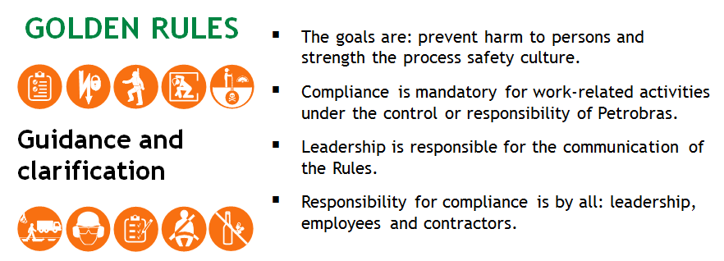

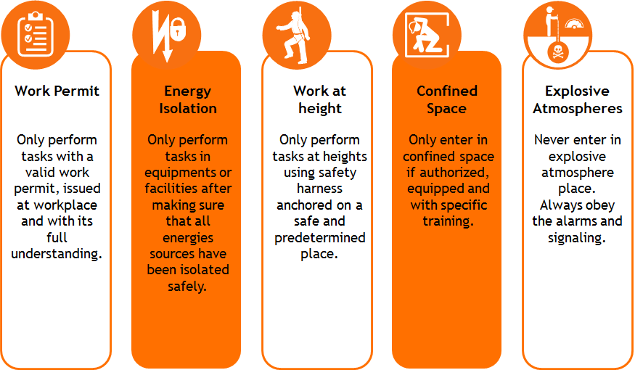

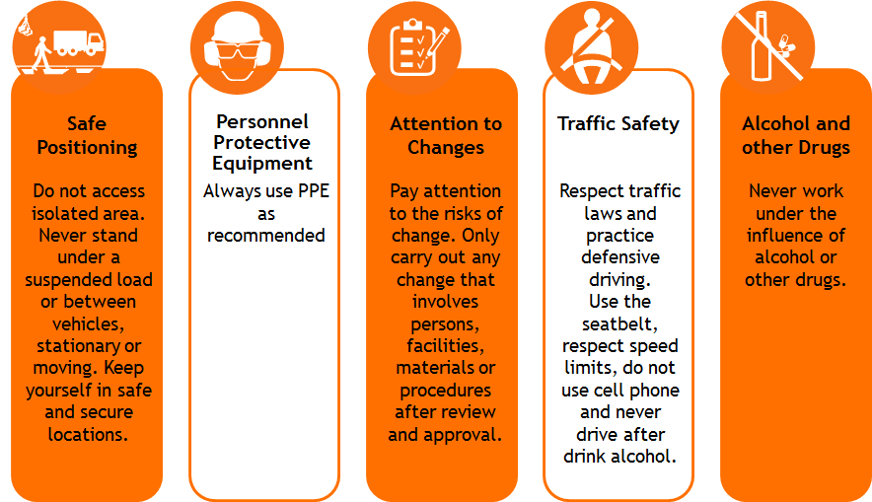

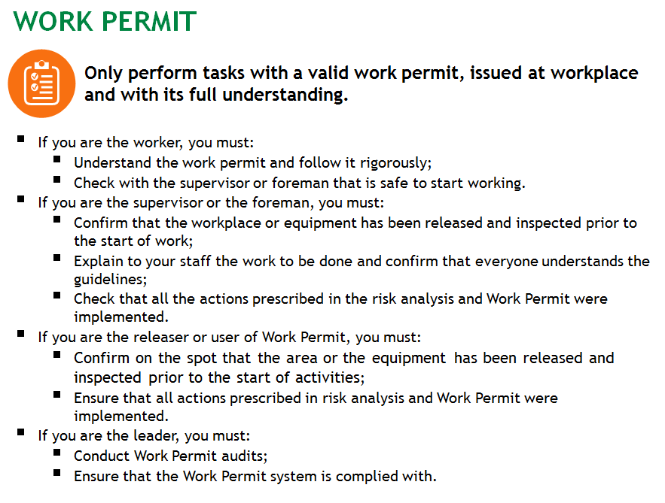

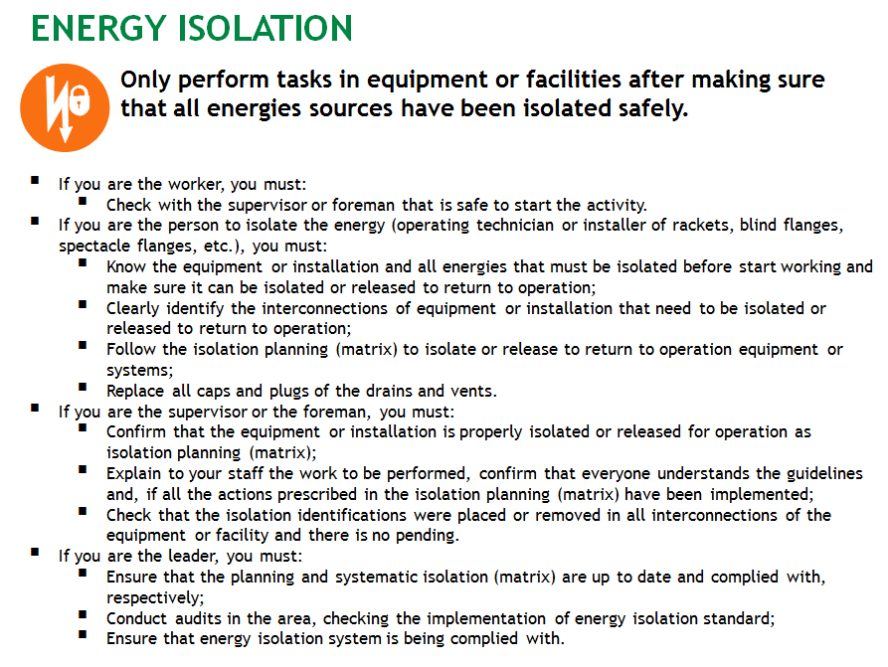

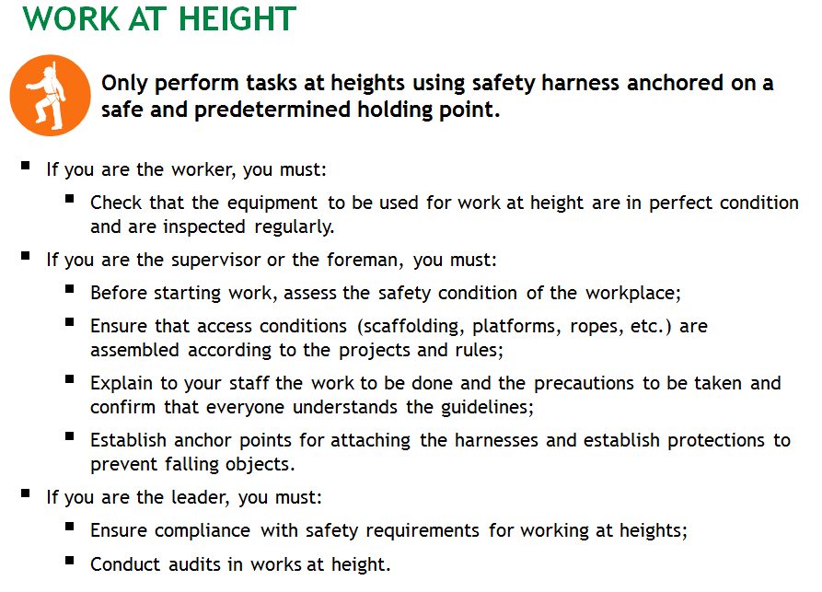

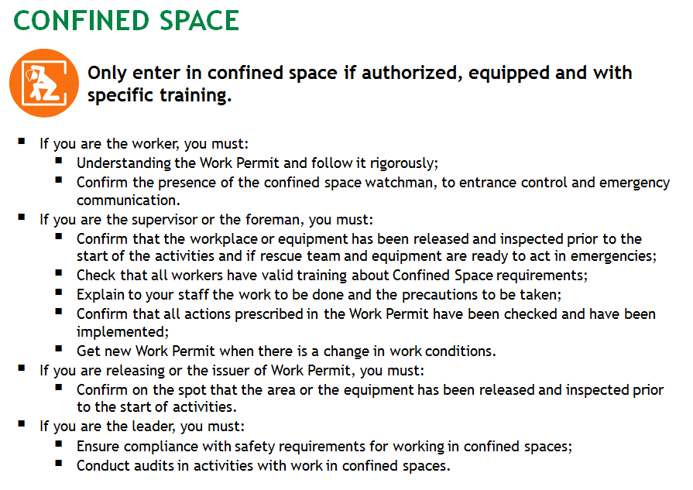

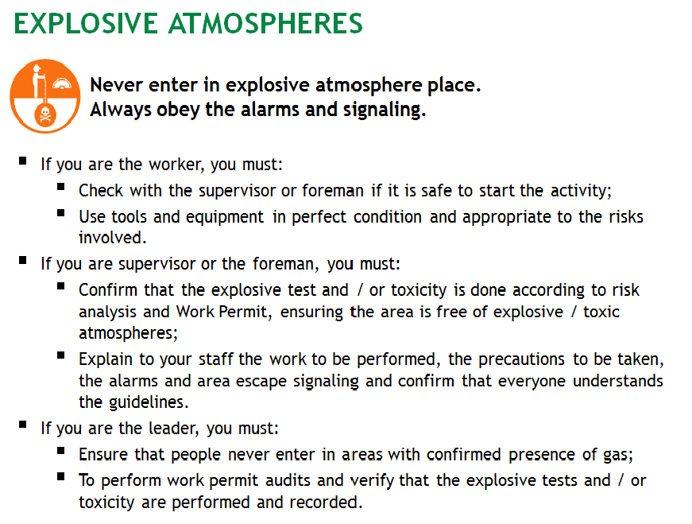

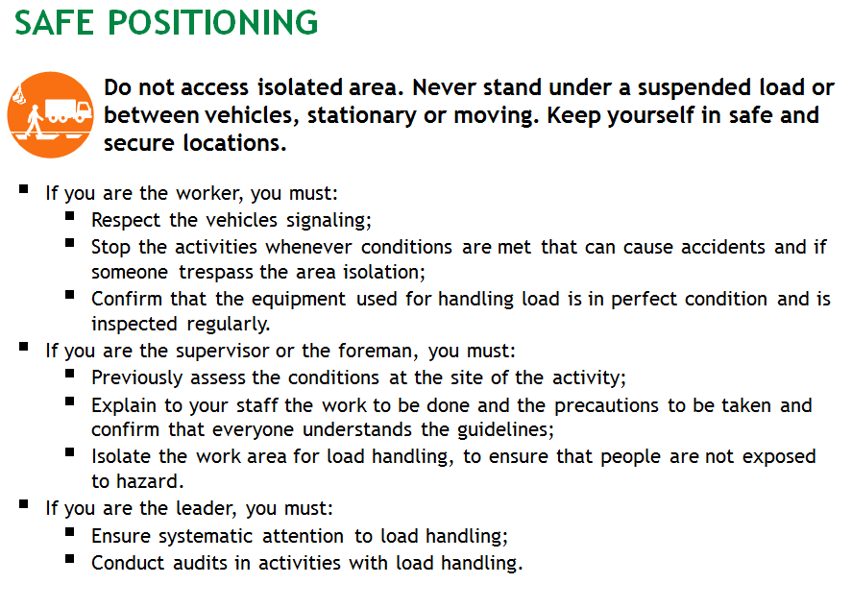

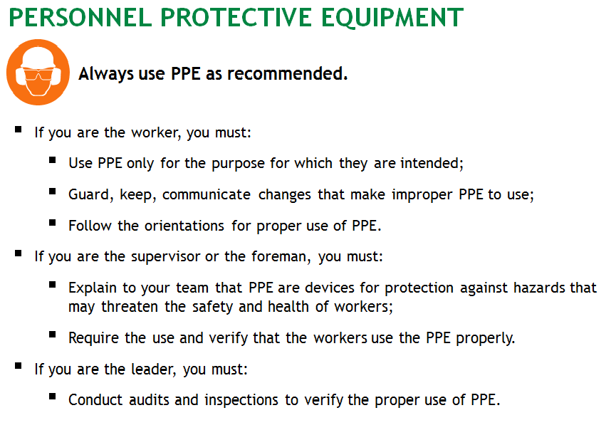

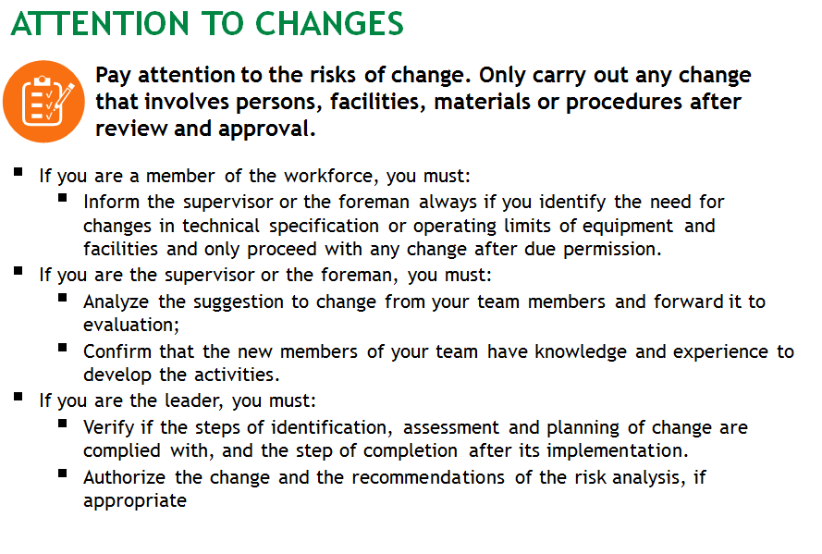

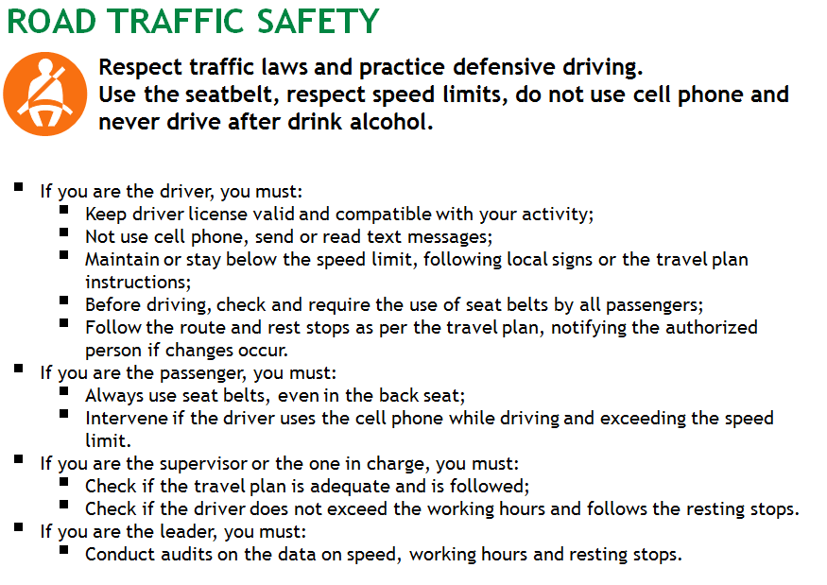

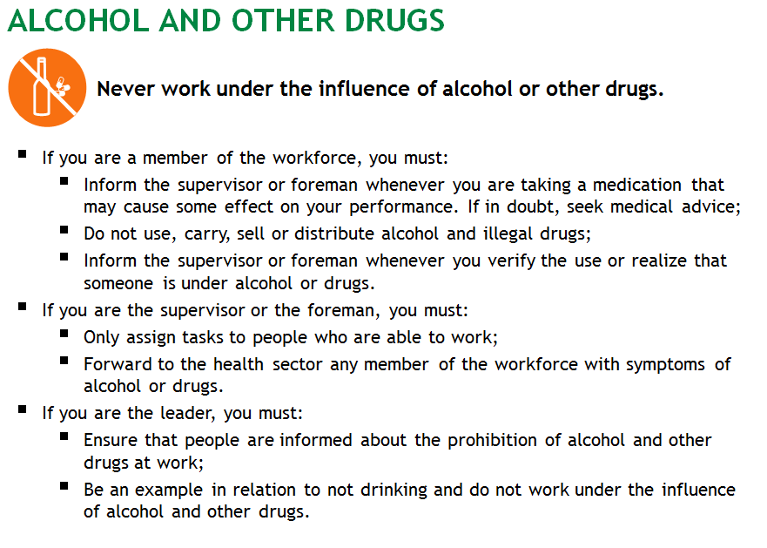

**Addendum – Template for FIA, RMA e REM**

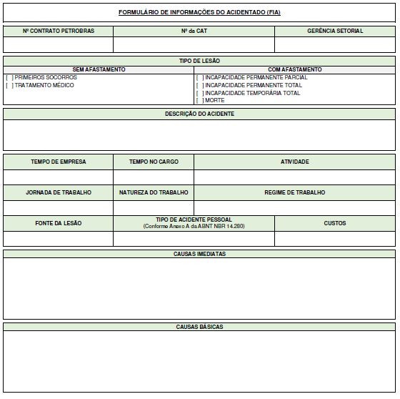







**Addendum 3 – Pos-Closing Assessment**

|  |
| --- |
| **Requirements as applicable** |
| There was no infraction notice due to non-compliance with legal and / or regulatory provisions. |
| Planned actions were implemented within the established and appropriate deadlines, including prevention programs and systems with emphasis on the HSE Golden Rules. |
| Periodic HSE meetings took place according to agreement timing and with the attendance of Leadership. |
| The identification, assessment and control of HSE risks took place, including review of risk analyzes and verification of the implementation of the actions resulting from the recommendations. |
| Operational and VCP procedures were developed, maintained and implemented. |
| HSE Management tools were applied, such as APR / AST, audits, IPS, PAD, PTW, VCP etc. |
| Performance monitoring and measurement were verified using HSE indicators. |
| Non-conformity treatment reports were issued. |
| Legal compliance assessment of processes and systematized activities. |
| Change management carried out in line with risk management. |
| Training, education and awareness programs were verified. |
| Communication carried out at all levels. |
| Documentation prepared and records made in accordance with the legislation. |
| Use of collective and individual protection equipment complied with applicable legislation. |
| Plan for corrective, preventive and predictive maintenance, followed according to procedures. |
| PTW designed and applied in line with risk management. |
| PRE, including assessment of contingency actions (performance and resources) and emergency response drills, implemented. |
| Identification, analysis of incidents, non-conformities, corrective action and preventive action and scope analysis carried out. |
| Inspections, evaluations and diagnosis carried out, based on checklists, containing an action plan for treatment of non-conformities carried out and concluded. |
| Inspections and advice on subcontractors carried out by the Corporate HSE and result of performance expressed in the RO (Occurrence Report). |
| Compliance in HSE of the subcontractor submitted. |
| The action plan, if applicable, arising from LV to high criticality contracts - Category III, comply with the defined metrics. |
| The result obtained in the CP (Award Criteria) demonstrated the commitment to HSE performance. |